Project Planning Phase
Project Planning Template (Product Backlog, Sprint Planning, Stories, Story points)

Date | 05 April 2026
Team ID | SWTID-2026-8642
Project Name | Streamlining Ticket Assignment for Efficient Support Operations
Maximum Marks | 5 Marks

Product Backlog, Sprint Schedule, and Estimation (4 Marks)
Use the below template to create product backlog and sprint schedule
Sprint | Functional  Requirement (Epic) | User Story  Number | User Story / Task | Story Points | Priority | Team  Members
Sprint-1 | User management | USN-1 | As a user, I can register in the system using email and password | 2 | High
Sprint-1 |  | USN-2 | As a user, I will receive confirmation after registration | 1 | High
Sprint-1 | Ticket creation | USN-3 | As a user, I can create a support ticket by entering issue details | 3 | High
Sprint-1 | Login | USN-4 | As a user, I can log into the system using email & password | 1 | High
Sprint-2 | Ticket management | USN-5 | As a system, I can categorize tickets based on issue type | 3 | High
Sprint -2 |  | USN-6 | As a system, I can assign priority (High/Medium/Low) to tickets | 2 | High
Sprint-3 | Agent management | USN-7 | As a user, I can view ticket status and reports in dashboard | 2 | Medium
Sprint -4 | Reporting | USN-8 | As an admin, I can generate reports for ticket performance | 2 | Medium

Project Tracker, Velocity & Burndown Chart: (4 Marks)
Sprint | Total Story Points | Duration | Sprint Start Date | Sprint End Date (Planned) | Story Points  Completed (as on  Planned End Date) | Sprint Release Date (Actual)
Sprint-1 | 20 | 6 Days | 12 mar 2026 | 18 mar 3036 | 20 | 29 Oct 2022
Sprint-2 | 20 | 6 Days | 19 mar 2026 | 23 mar 2026
Sprint-3 | 20 | 6 Days | 24 mar 2026 | 30 mar 2026
Sprint-4 | 20 | 6 Days | 31 mar 2026 | 05 Apr 2026

Velocity:
Imagine we have a 10-day sprint duration, and the velocity of the team is 20 (points per sprint). Let’s calculate the team’s average velocity (AV) per iteration unit (story points per day)
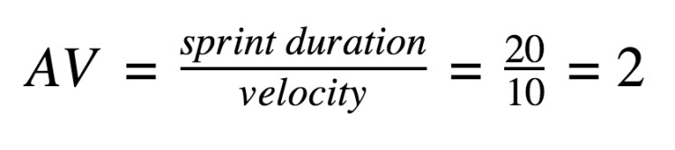

Burndown Chart:
A burn down chart is a graphical representation of work left to do versus time. It is often used in agile software development methodologies such as Scrum. However, burn down charts can be applied to any project containing measurable progress over time.

